WEB DESIGN COURSEWORK
DATE DUE: 1st MARCH to presented
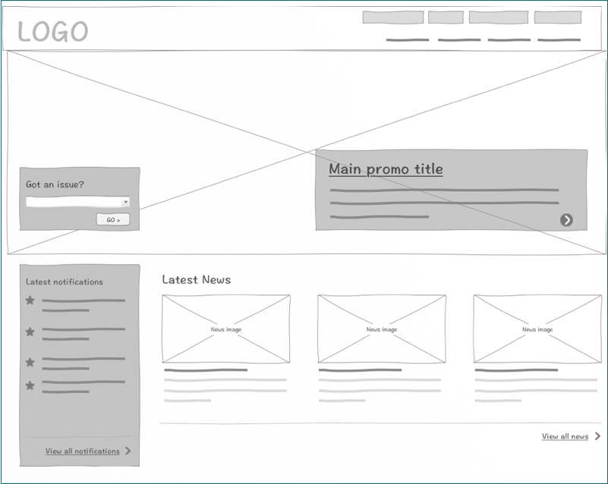

- Create a personal website with a similar structure as the wire frame (mock up) above .
- Your page should have at-least 4 pages minimum,all pages should have a menu at the top with name of the current page highlighted as the current menu.
- All pages should have a single style-sheet styling all the pages
- Document at least 10 CSS features you have used and write short notes about how those features were used.
- All content should be unique to your experience

